SOP: User Permission and Report Emails
Module | User Permission and Report Emails
Who uses it | Super Admin
Version | 1.0
Issued | 21 Oct 2026
Screenshots are taken from the HRMS test copy. Names, dates and numbers are examples only.

1. Purpose
Super Admin controls who may create users and projects, and who receives the automatic report emails.
Super Admin also has everything an Admin has. For those screens use the Admin SOPs and SOP - Manager - Reports (Overview, Billable Report, QA Report, User Monthly Goal, KRA, Tracker Report and Task EOD Report).

2. User Permission
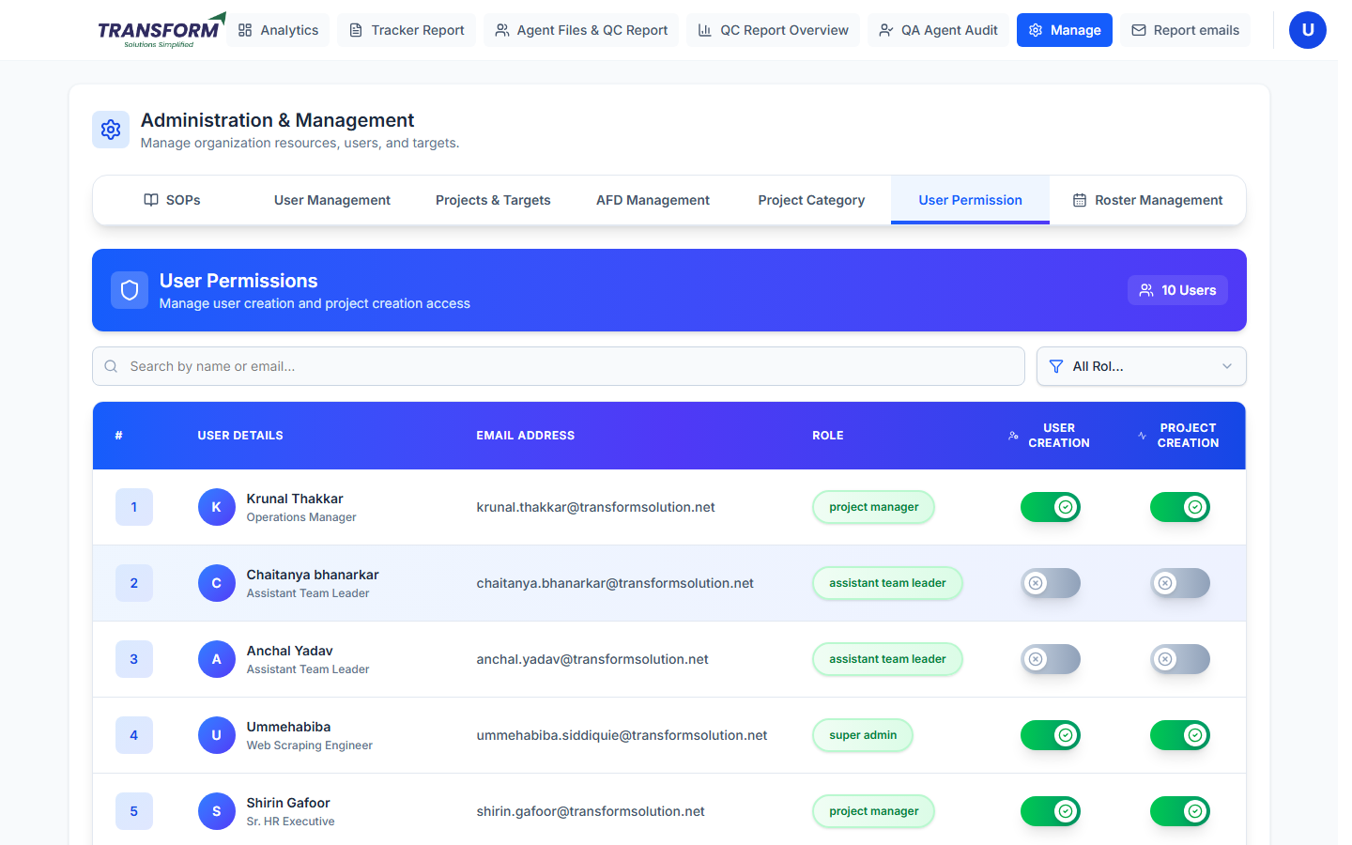
Figure 1: User Permissions
1. Manage > User Permission. Search by name or email, or filter by role.
2. Switch User Creation on to let that person add users; switch Project Creation on to let them add projects. Changes save at once.

3. Report emails
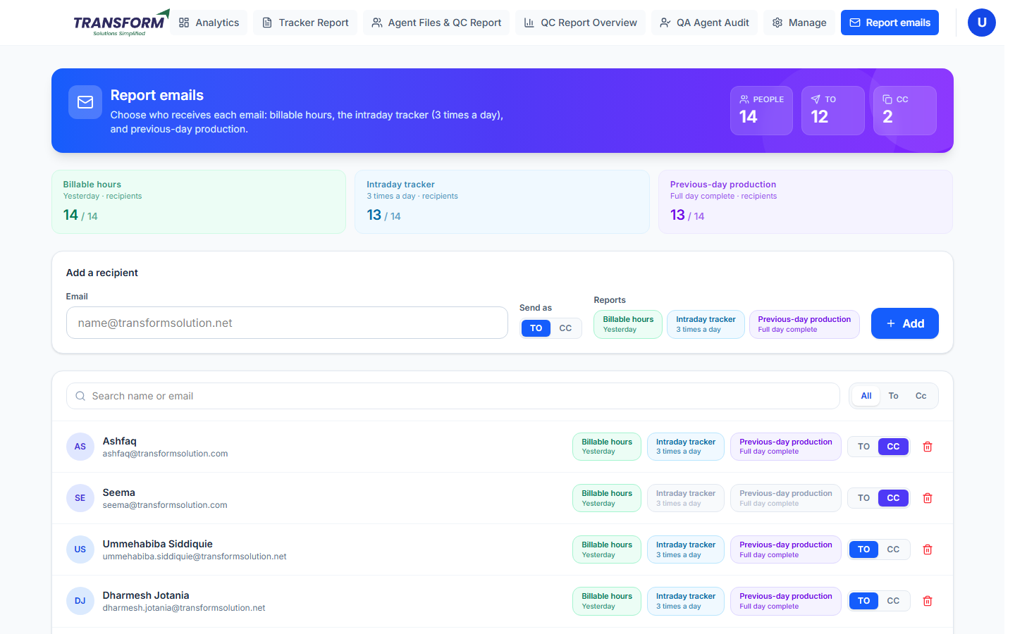
Figure 2: Report emails
Email | When it is sent
Billable hours | Yesterday's billable hours.
Intraday tracker | Three times a day.
Previous-day production | When the previous full day is complete.

1. Add a recipient: type the email, choose TO or CC, tick the reports they should get and click Add.
2. In the list, switch each report on or off per person, or change TO / CC.
3. Use the bin to remove someone. Search and the All / To / Cc filters help with long lists.
The Monday weekly goal email is not set up here. It goes automatically to Admins and Project Managers (all agents) and to each Assistant Manager / Team Lead (their own agents). See SOP - Manager - Reports, section 10.

4. Common problems
Problem | What to do
Someone did not get an email | Check they are listed with that report switched on.
A manager cannot add users | Switch on User Creation for them.

